  Programming Fundamentals - LAB | Name: Mohsin Ali  Roll Number: 25P-0545

Q#1: Write a C program to read name and marks of n number of students and store them in a file
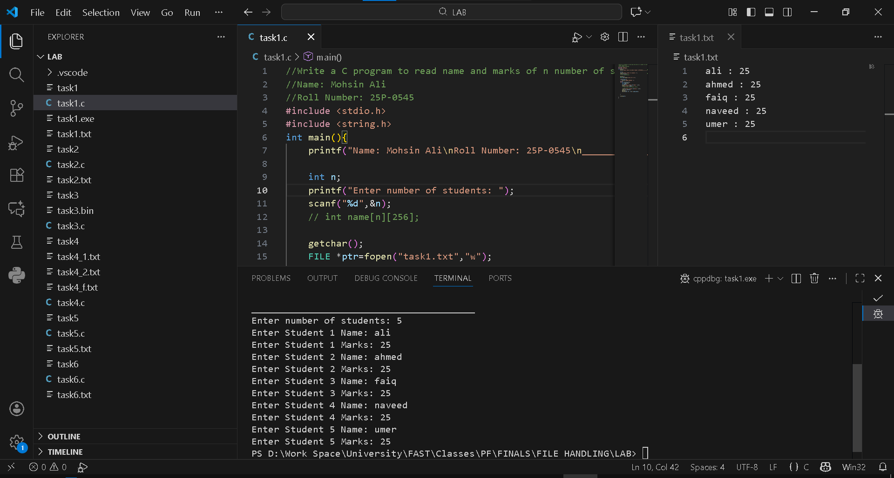
CODE:
//Write a C program to read name and marks of n number of students and store them in a file
//Name: Mohsin Ali
//Roll Number: 25P-0545
#include <stdio.h>
#include <string.h>
int main(){
printf("Name: Mohsin Ali\nRoll Number: 25P-0545\n________________________________________\n");

int n;
printf("Enter number of students: ");
scanf("%d",&n);
// int name[n][256];

getchar();
FILE *ptr=fopen("task1.txt","w");

if(ptr==NULL){
printf("ERROR OPENING! ");
}else{
for(int i=0;i<n;i++){
char name[256];
int marks;
printf("Enter Student %d Name: ",i+1);
scanf("%[^\n]s",name);
// fgets(name,sizeof(name),stdin);

printf("Enter Student %d Marks: ",i+1);
scanf("%d",&marks);
getchar();
fprintf(ptr,"%s : %d\n",name,marks);
}
fclose(ptr);
}
}

Q#2: Write C program to read name and marks of n number of students from and store them in a file. If the file previously exits, add the information to the file.

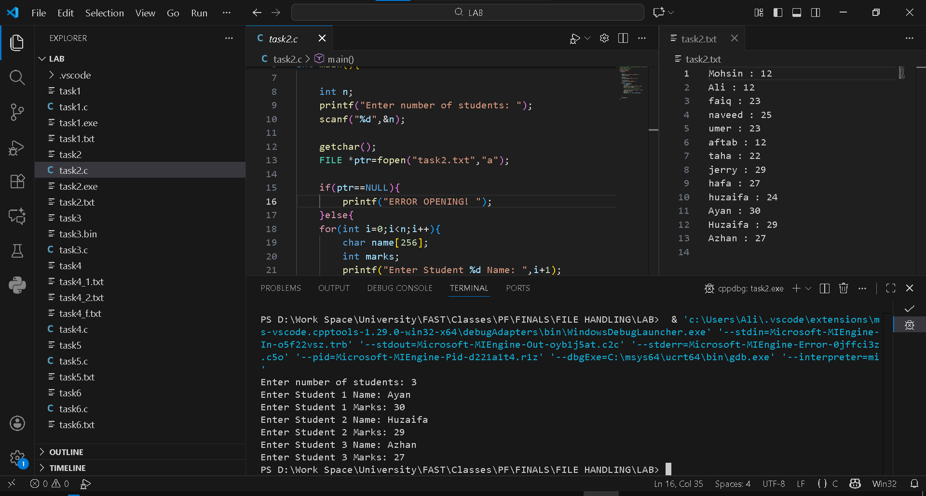
CODE:
//Write a C program to read name and marks of n number of students and store them in a file
//Name: Mohsin Ali
//Roll Number: 25P-0545
#include <stdio.h>
#include <string.h>
int main(){
int n;
printf("Enter number of students: ");
scanf("%d",&n);
getchar();
FILE *ptr=fopen("task2.txt","a");
if(ptr==NULL){
printf("ERROR OPENING! ");
}else{
for(int i=0;i<n;i++){
char name[256];
int marks;
printf("Enter Student %d Name: ",i+1);
scanf("%[^\n]s",name);
// fgets(name,sizeof(name),stdin);
printf("Enter Student %d Marks: ",i+1);
scanf("%d",&marks);
getchar();
fprintf(ptr,"%s : %d\n",name,marks);
}
fclose(ptr);
}
}

Q#3: C program to write all the members of an array of structures to a file using fwrite(). Read the array from the file and display on the screen.

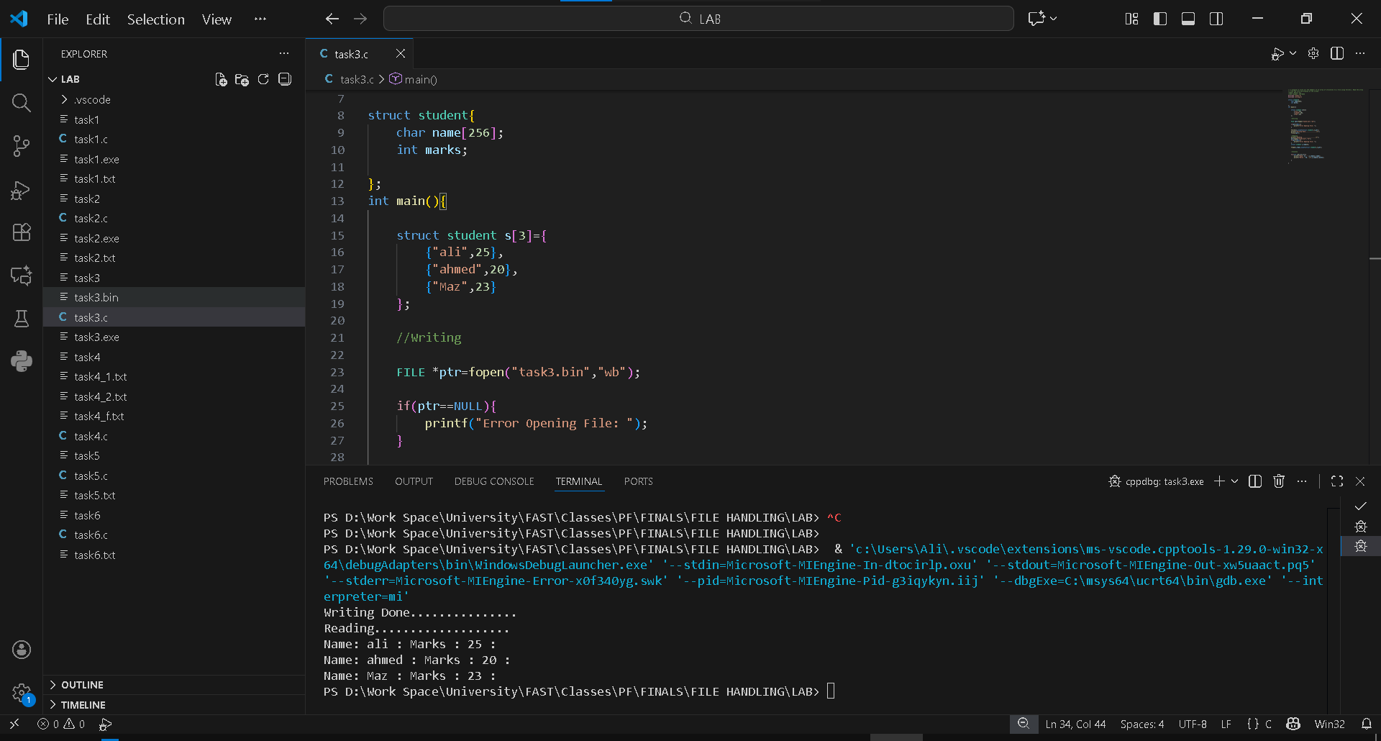
CODE:
// C program to write all the members of an array of structures to a file using fwrite(). Read the array
// from the file and display on the screen.
//Name: Mohsin Ali
//Roll Number: 25P-0545
#include <stdio.h>
#include <string.h>

struct student{
char name[256];
int marks;

};
int main(){

struct student s[3]={
{"ali",25},
{"ahmed",20},
{"Maz",23}
};

//Writing

FILE *ptr=fopen("task3.bin","wb");

if(ptr==NULL){
printf("Error Opening File: ");
}

fwrite(s,sizeof(struct student),3,ptr);
printf("Writing Done...............\n");
fclose(ptr);

//Reading
printf("Reading...................\n");
ptr=fopen("task3.bin","rb");
if(ptr==NULL){
printf("Error Opening File: ");
}
struct student s_read[3];

fread(s_read,sizeof(struct student),3,ptr);

//Display

for(int i=0;i<3;i++){
printf("Name: %s : ",s_read[i].name);
printf("Marks : %d : \n",s_read[i].marks);

}

}

Q#4: Write a C program to create 2 text files and store some text inside them. Then read these 2 files into the program and merge the text into a 3rd text file.
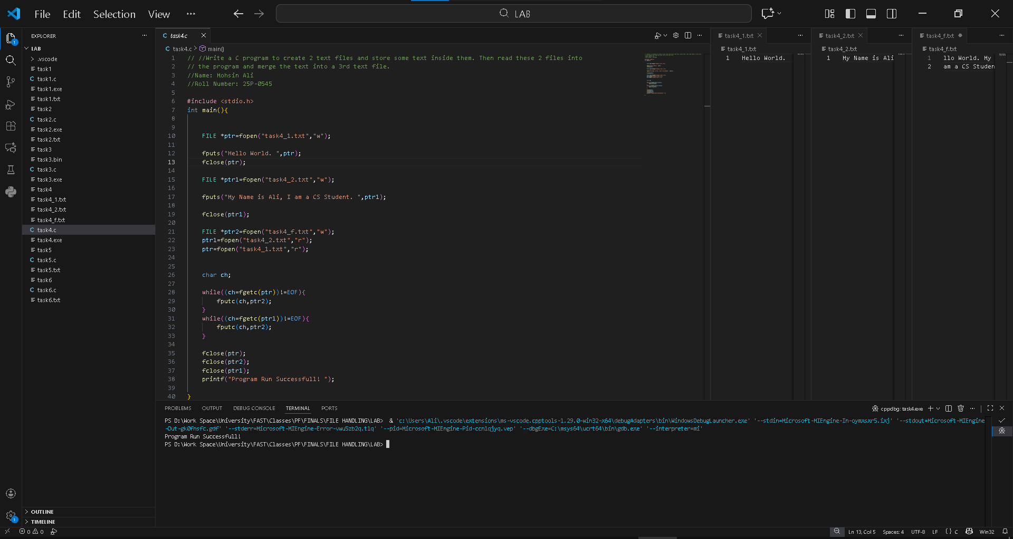
CODE:
// //Write a C program to create 2 text files and store some text inside them. Then read these 2 files into
// the program and merge the text into a 3rd text file.
//Name: Mohsin Ali
//Roll Number: 25P-0545
#include <stdio.h>
int main(){
FILE *ptr=fopen("task4_1.txt","w");
fputs("Hello World. ",ptr);
fclose(ptr);
FILE *ptr1=fopen("task4_2.txt","w");
fputs("My Name is Ali, I am a CS Student. ",ptr1);
fclose(ptr1);
FILE *ptr2=fopen("task4_f.txt","w");
ptr1=fopen("task4_2.txt","r");
ptr=fopen("task4_1.txt","r");
char ch;
while((ch=fgetc(ptr))!=EOF){
fputc(ch,ptr2);
}
while((ch=fgetc(ptr1))!=EOF){
fputc(ch,ptr2);
}
fclose(ptr);
fclose(ptr2);
fclose(ptr1);
printf("Program Run Successfull! ");
}

Q#5: Write C Program that Reads a Text File and Counts the Number of Times a Certain Letter Appears in the Text File
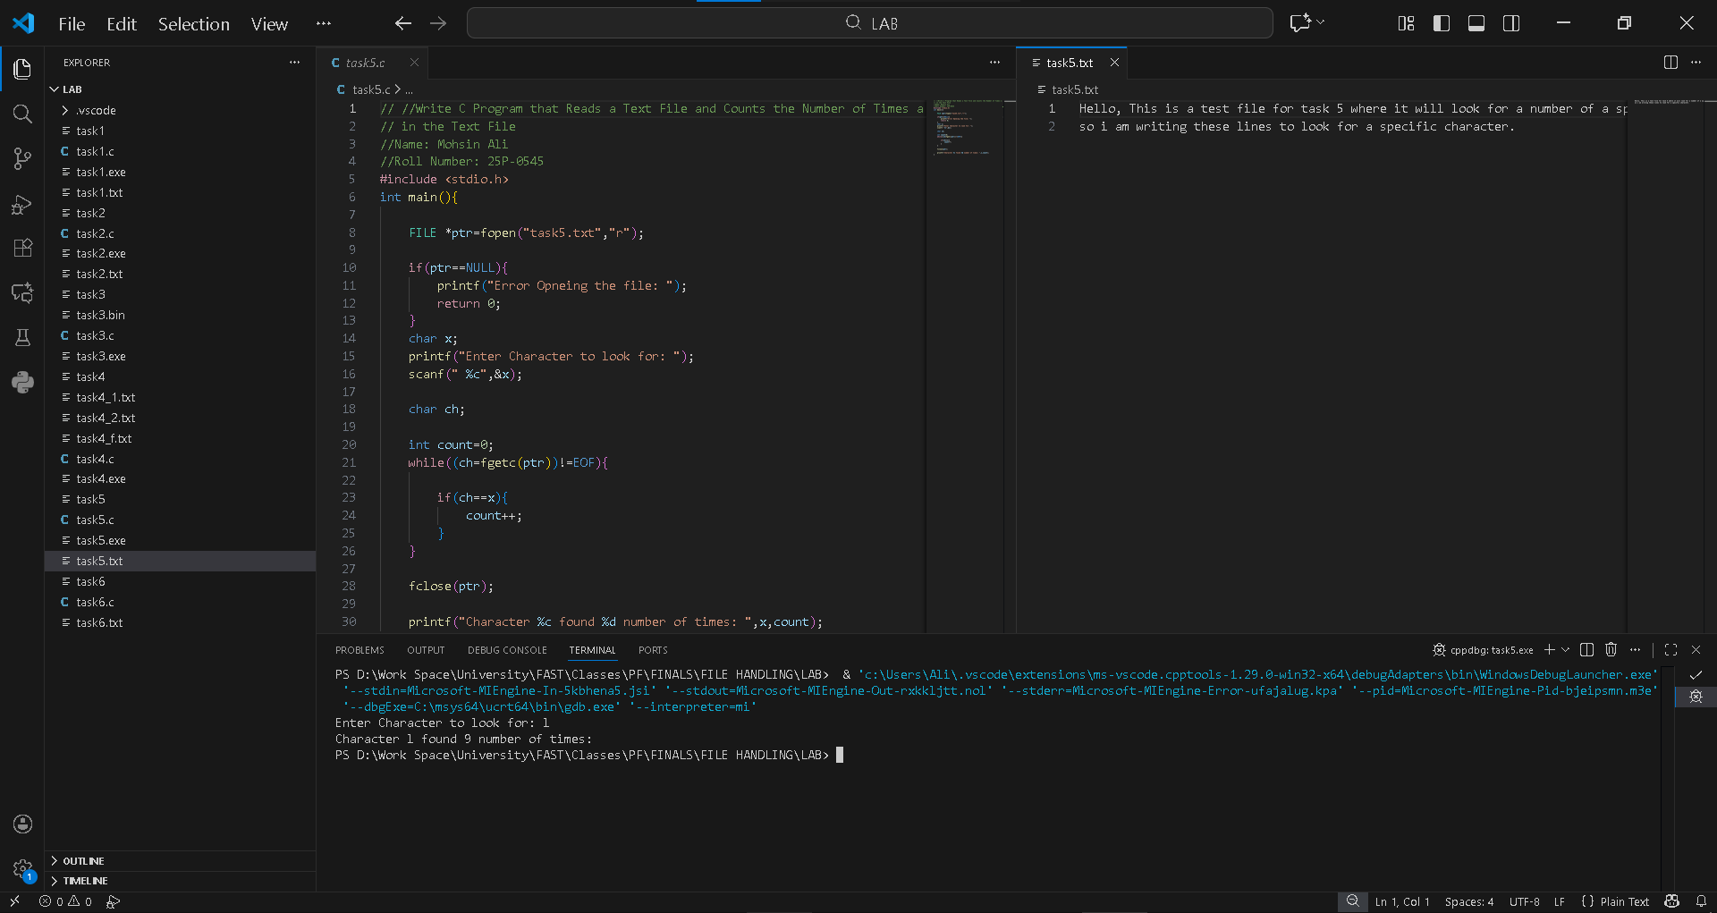
CODE:
// //Write C Program that Reads a Text File and Counts the Number of Times a Certain Letter Appears
// in the Text File
//Name: Mohsin Ali
//Roll Number: 25P-0545
#include <stdio.h>
int main(){
FILE *ptr=fopen("task5.txt","r");
if(ptr==NULL){
printf("Error Opneing the file: ");
return 0;
}
char x;
printf("Enter Character to look for: ");
scanf(" %c",&x);
char ch;
int count=0;
while((ch=fgetc(ptr))!=EOF){
if(ch==x){
count++;
}
}
fclose(ptr);
printf("Character %c found %d number of times: ",x,count);
}

Q#6: Consider a String entered by the user which he wants to encrypt and then decrypt the information. Perform this functionality via the filling technique by first inserting the encrypted text in the file then read the encrypted text to decode it back to string.
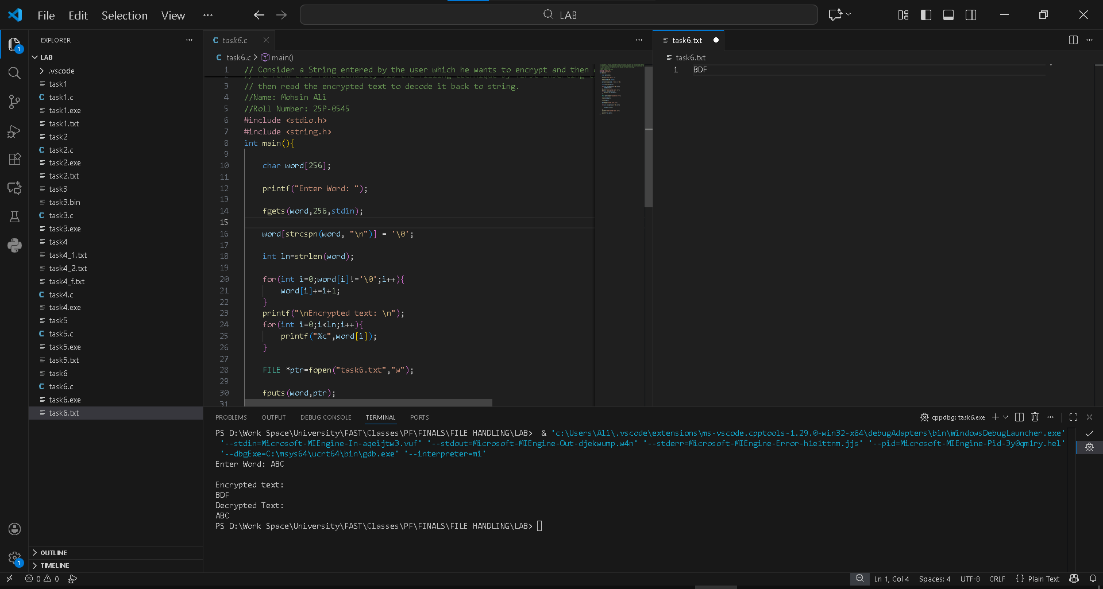
CODE:
// Consider a String entered by the user which he wants to encrypt and then decrypt the information.
// Perform this functionality via the filling technique by first inserting the encrypted text in the file
// then read the encrypted text to decode it back to string.
//Name: Mohsin Ali
//Roll Number: 25P-0545
#include <stdio.h>
#include <string.h>
int main(){
char word[256];

printf("Enter Word: ");

fgets(word,256,stdin);

word[strcspn(word, "\n")] = '\0';

int ln=strlen(word);

for(int i=0;word[i]!='\0';i++){
word[i]+=i+1;
}
printf("\nEncrypted text: \n");
for(int i=0;i<ln;i++){
printf("%c",word[i]);
}

FILE *ptr=fopen("task6.txt","w");

fputs(word,ptr);

fclose(ptr);

ptr=fopen("task6.txt","r");

for(int i=0;word[i]!='\0';i++){

word[i]-=(i+1);

}
printf("\nDecrypted Text: \n");

printf("%s",word);
}

